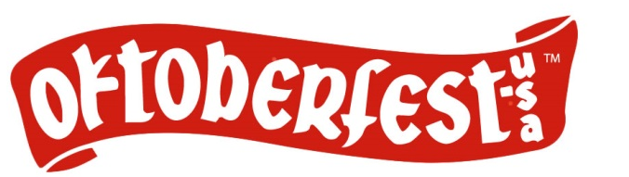
Images and information regarding the 2017 Oktoberfest Button are embargoed from public distribution until
7:30 p.m. on Friday, March 10, 2017. Thank you!

2017 Oktoberfest Button Designer: David Riel ( pronounced REEL)

The La Crosse community will actually be getting a “two for one” with the unveiling of the 2017 Oktoberfest Button at the 4th annual Forks and Corks fundraiser on March 10 at the La Crosse Center. The extra add-on is that this unveiling will be the first time selected button designer David Riel will have his work shared publicly in the community.

“My design reflects my perspective that the Oktoberfest celebration is all about people. I wanted to create a character design that captured the joy and excitement people feel for Oktoberfest. This design is also special to me, because it's the first time the La Crosse community will get to see my artwork.”

The 2017 theme – “Prost to the Midwest Coast” – has some fun with Wisconsin’s distance to the nation’s actual coastal borders and lets our guests gently know we are not exactly lacking access to great bodies of water. The notion of “coast” was also not lost on David, a native of Boston, who like many other newcomers has come to appreciate the beauty of the La Crosse area.

“I moved to La Crosse in 2012 when my wife Tiffany accepted a new job offer. Since then, we have fully embraced La Crosse as our new home. I always like to tell people, ‘I traded skyscrapers for bluffs’. Even though La Crosse and Boston are very different, they both share the attributes of any great city. With its rich history, remarkable architecture, and natural beauty, La Crosse is a source of inspiration and an ideal setting for me to perfect my craft,” says David.

David and his wife purchased a home on the North Side, not knowing the transformation that takes place in their neighborhood on the last Thursday of September. “One of my favorite parts about Oktoberfest is that it takes place right in my front yard. In 2014, we bought our first home on Caledonia Street, unaware that the Torchlight Parade passes right in front of our house. It was a welcomed surprise, and adds to the richness of being a La Crosse resident. After my first Torchlight Parade in 2014, I knew I had to enter the Button Design contest.” David also submitted designs in 2015 and 2016. “They say ‘the third time's the charm’, and that was certainly the case for me.”

David holds a Bachelor of Fine Arts in Illustration from the Massachusetts College of Art and worked professionally in the Boston area crafting portraits and caricatures for various individuals and companies, making production designs for toys and text books, as well creating interactive animations and web design. His mediums range from oils to digital. “The Button Design Contest is a great way to expose artists to the community, using art to promote an event that people cherish. I'm honored that my design was chosen this year.”

